Instructions

Attached information regarding **medical insurance-info** (Purchasing Insurance)

Contact Information at Harel-Yedidim: Mr. Amos Gilboa/ Mrs. Einat Cohen [y_health@yedidim.co.il](mailto:y_health@yedidim.co.il)

**Here are the forms you need to fill:**

1 **Non-Resident Declaration**.

2 **Personal questionnaire** (2 pages).

3 **Application for Migdal Makefet Ishit Pension Fund** – form no. **130**, note: This form is a translation of the Hebrew form into English. For application, please sign only the Hebrew form.

4 **Application for Migdal Makefet Ishit Pension Fund** – form no. **302** – in Hebrew (5 pages).

On page 1 mark number 1: (it’s the default track)

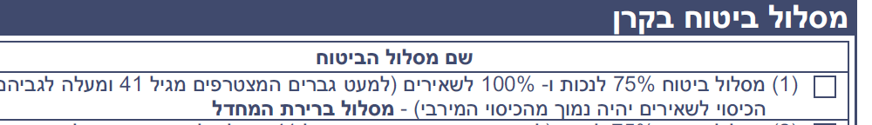

On page 2 mark the first option:

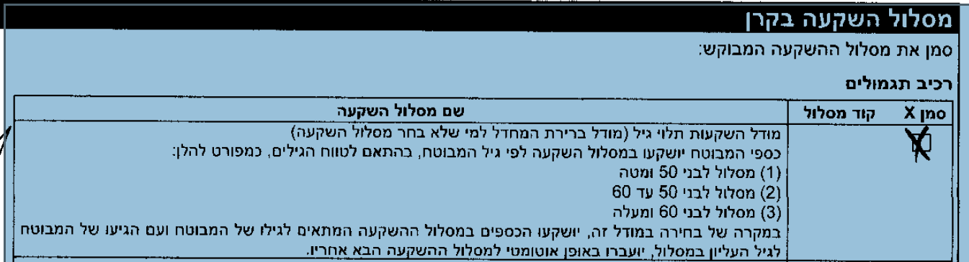

On page 3 mark the firs one:

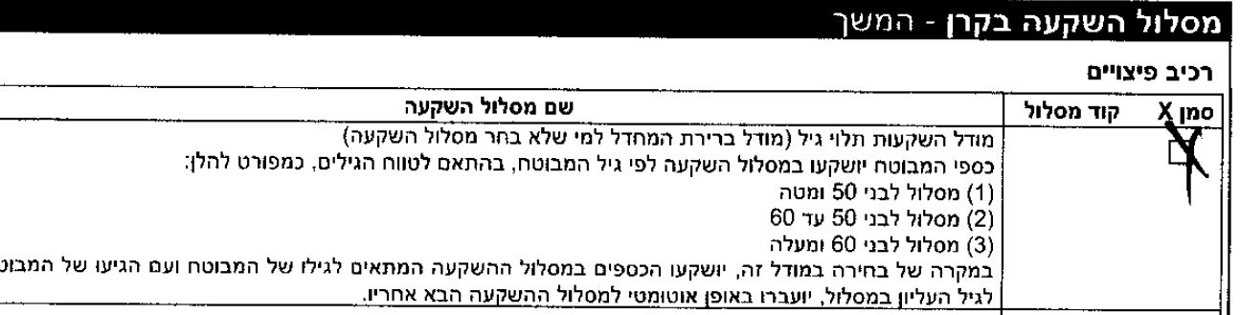

On page 4 please sign in two spots near the star:

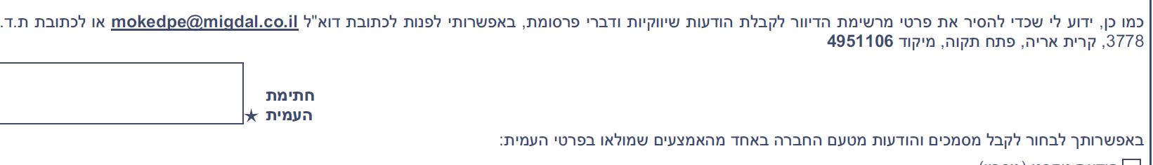

- near the first star: **date** from the right and signature from the left.

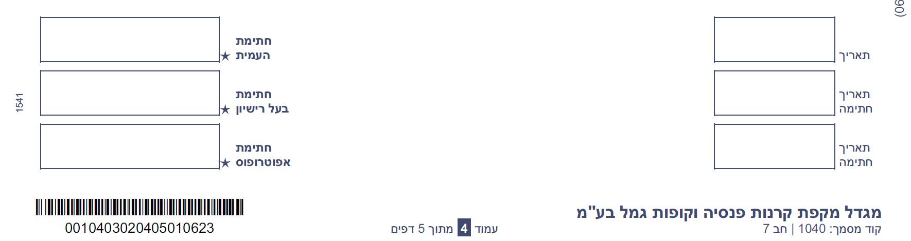



5_**Confirmation of acceptance of a new insured with a foreign passport** – form no. **2902**. this form is in Hebrew.

Please sign on the right side



**And send me the following details:**

Full name:

Passport number:

Country of origin:

Date of birth:

Home address in Israel:

Married: yes / no

Is your spouse an Israeli citizen: yes / no

“KUPAT HOLIM” = HMO = Health service organization: yes / no. If yes: the name of HMO: Maccabi / Clalit / Meuhedet… and date of joining.

Contact person In Israel (Probably me) and their ID number and home address.

Other contact person in Israel (maybe your academic host).

What is your connection to Israel / your status title – PhD Student / academic guest / post doc.

Start date of residence in Israel.

Employer name (Technion)

What is your job title (Post-Doctoral / Academic Guest)

Mark the pension:

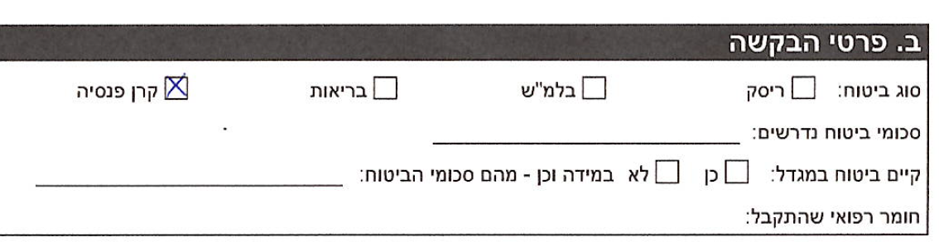

6_ **Joining the Pension Fund Makefet Ishit and/or Makefet Complementar**y

( 7_in Hebrew Joining the Pension Fund Makefet Ishit and/or Makefet Complementary)

**Please also please send:**

Copy of your passport

Copy of your work visa

Confirmation of medical insurance

**Your contact person:**

**Omri Nelson** – manager

+972-50-6619646

[omrin@migdal.co.il](mailto:omrin@migdal.co.il) Migdal.co.il

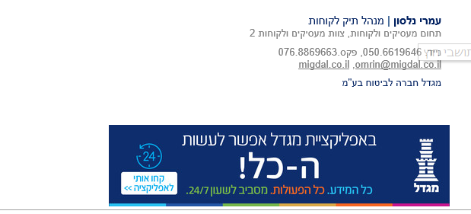

Written by **Anat Glass** – Coordinator of Graduate Studies and Academic Affairs, The Department of Humanities and Arts, Technion.

[anatg@technion.ac.il](mailto:anatg@technion.ac.il)